COMPARISON OF Ryanair AIRLINES FINANACES 2021 VS 2022 (A2)

AIR TRANSPORT FINANCE & BUISNESS STRATERGIES - TH40102E



word Count: 1,961

Student ID: 21398211



CONTENTS

1.0 Introduction 2

2.0 Financial Analysis 2

2.1 Income Analysis & Comparison 2

2.1.1 Available Seat Miles (ASM) 2

2.1.2 Revenue per Available Seat Mile (RASM) 3

2.1.3 Ancillary Revenue 4

2.2 Cost Analysis and Comparison 5

2.2.1 Cost per Available Seat Mile (CASM) 5

2.2.2 Fuel 6

2.2.3 Staff Costs 7

2.2.4 Depreciation & Amortization 8

3.0 Liquidity 8

4.0 Debt 9

5.0 Conclusion 9

6.0 References 9

7.0 Appendix 13

7.1 Appendix A 13

7.2 Appendix B 17

LIST OF TABLES

Table 1 – Operating Income, Revenue & Margin 3

Table 2 – RASM & Load Factor 4

Table 3 – Ancillary Revenue 5

Table 4 – CASM 6

LIST OF FIGURES

Figure 1 - ASM 4

Figure 2 - RASM 5

Figure 3 - CASM 7

1.0 Introduction

This report will look at the financial reports of the low-cost carrier (LLC) Ryanair. This will help build a portfolio to understand the commercial performance of airlines using analytics to achieve this. More specifically using the reports from 2021 and 2022, while benchmarking them against their competitors to help paint a broader picture.

Covid-19 had worldwide affects on the airline industry and Ryanair were not protected from it either (Sun et al., 2022). The tight border controls and restrictions of movement meant that leisure travel plummeted (Chinazzi et al., 2020). However, 2022 saw Ryanair recover traffic but not that which they had pre-Covid (Ryanair, 2022).

2.0 Financial Analysis

2.1 Income Analysis & Comparison

|  |  |  |  |
| --- | --- | --- | --- |
| ITEM | 2021 | 2022 | % DIFFERENCE |
| OPERATING  REVENUE | €1,635,800,000 | €4,800,900,000 | 193% |
| OPERATING  INCOME | -€839,400,000 | -€339,600,000 | -60% |
| OPERATING  MARGIN | -51.31% | -7.07% | -86% |

Table 1 – Operating Income, Revenue & Margin

The table shows that between 2021 and 2022 there has been an increase in operating revenue and income. Revenue changed drastically with an increase of 193%, which shows that due to the traffic picking revenue has managed to double in its amount. Looking at the operating income, it shows that there was a decrease of 60% in 2022 compared to 2021. The operating income denotes the income a company obtains from its core operations and excludes the costs of running the operation (Hayes, 2023). This would be evident in other airline operations as most companies had a significant increase in their revenue, especially during the second quarter of the year of 2022, some even surpassed their pre-covid volume (Sun et al., 2023).

The profit margin is a good indicator of how much a company can convert each euro of revenue into profit/income (Segal, 2024). As shown by the figure above, even though the revenue was increased significantly, the operating income was much lower in 2022 compared to 2021. This is evident in the operating margin and reasons for this could be due to multiple factors, however, Ryanair stated that the higher fuel prices which were 237% higher than the previous year, were a notable reason for the lower operating income (Ryanair, 2022a).

2.1.1 Available Seat Miles (ASM)

2021 saw a huge drop in ASM which resulted in lower ticket sales, however, the following year it had increased by 203%, which is supported by the increase in operating revenue. Figure 1 below shows the fluctuations of ASM over the last 5 years. The closing of borders and restrictions on air travel contributed to this (Barnett, 2020).

Figure 1 - ASM Source: Author, Adapted from: (Ryanair, 2022b)

2.1.2 Revenue per Available Seat Mile (RASM)

|  |  |  |  |
| --- | --- | --- | --- |
|  | 2021 | 2022 | % Difference |
| RASM | €0.05 | €0.05 | 84% |
| Load Factor | 73.33% | 82.42% | 112% |

Table 2 – RASM & Load Factor

RASM is a metric that is used by the airlines in order to measure how much revenue an airline can obtain for every seat mile that is flown. It is one of the more favoured standard metrics due to the inclusivity of total revenue not just passenger fare. However, another reason for this is that airlines tend to prefer metrics which show them in the best light (Kenton, 2021).

The RASM is obtained by dividing the total revenue by the ASM (Hazel, 2018). The goal of this is to understand the Cost per Available Seat Mile (CASM), which indicates how much it costs to fly that seat per mile, to try to the RASM as high as possible and decrease CASM to provide maximum profitability. Ryanair has a lower RASM in 2022 than 2021, as during COVID-19 due to limited ASM fare prices could be higher, however, when restrictions were lifted and availability went up it diluted their market leading to a lower RASM.

By looking at the Break-Even (B.E) load factor, which displays the minimum amount of passengers required to level with the operational cost (Steiner, 1967) it is deduced that 2021 had a more financial strain than 2022. As the B.E load factor for 2021 was 108%, as an oppose to their actual load factor of 73%, which explains why their operation income was so low. Since they would have to fill more seats than they had available just to break even. As for 2022, the B.E load factor was 88%, but in eventuality, they had only managed 82%. The net income demonstrates this as both years were in financial loss for Ryanair, however, 2021 was more substantial as they were much further away from their B.E load factor. Ryanair mainly attributes this to the rise in operational costs that had been incurred due to the surge in passenger demands.

Figure 2 - RASM Source: Author, Adapted From: (EasyJet, 2022), (Wizz Air, 2022)

As shown in Figure 2 compared with other LLC’s Ryanair had still managed to have the highest RASM despite it being their lowest profiting year. This was achieved by using alternative fuel and cost-saving tactics to reduce the cost for passengers, thus driving more sales (Ryanair, 2022a).

2.1.3 Ancillary Revenue

|  |  |  |  |  |
| --- | --- | --- | --- | --- |
| ITEM | ANCILLARY REVENUE | | % of REVENUE | |
| YEAR | 2021 | 2022 | 2021 | 2022 |
| RYANAIR | €599,800,000 | €2,148,400,000 | 37% | 45% |
| EASYJET | €495,550,000 | €1,852,450,000 | 30% | 29% |
| WIZZAIR | €412,300,000 | €931,400,000 | 56% | 56% |
| EMIRATES | €474,220,000 | €929,150,000 | 6% | 6% |

Table 3 – Ancillary Revenue

Ancillary revenue constitutes as airlines main form of revenue. More importantly for LLCs since they do not charge as much for the base fares. However, compensate for it through ancillary revenues (Hao, 2014). In 2022 Ryanair, had increased their ancillary revenue to 45%, which is nearly half the total revenue. Their main competitor in the UK, EasyJet had earned significantly less revenue than Ryanair, however, their ancillary revenue was attributed to more than half their total revenue. On the contrary, Full Service Network Carriers (FSNC) such as Emirates, only rely a small amount on ancillary revenue, in fact only brining in 6% in the form of ancillaries. However, a caveat is that Emirates manages to rake in a similar amount from the lower end of airlines in the table. Which goes to show that other factors have to be taken into consideration to understand if it a profitable strategy. This is attributed due to the fact that FSNC include services, such as extra baggage and food included into the base ticket price. Whereas LLCs provide this as extra services, thus reducing the base ticket price and catering to a different market (Soyk et al., 2018). Ryanair rely on this business model even going as far as to wanting to charge passengers to use the lavatory on their flights, if it means that they could reduce the base air fare for other passengers (The Guardian, 2009).

2.2 Cost Analysis and Comparison

2.2.1 Cost per Available Seat Mile (CASM)

|  |  |  |  |
| --- | --- | --- | --- |
|  | 2021 | 2022 | % DIFFERENCE |
| CASM (€) | 0.0824 | 0.0565 | -32% |
| TOAL EXPENSES (€) | €2,475,200,000 | €5,140,500,000 | 108% |

Table 4 – CASM

CASM is used to work out how much it will cost for an airline to fly one seat one mile, this is a very useful metric to analyse the cost factors, and in conjunction with other metrics can clearly show if a company is making money or not (KÖSE & AKTAN, 2022).

The total expenses had increased from 2021 by another 108%, however the CASM was decreased by 32%. This could be since fuel consumption had increased due to the increase in ASM, thus meaning the expenses had also increased. However, the CASM, was decreased due to the fact that Ryanair have adopted the Boeing 737-8200 called the ‘GameChangers’, which burned less fuel due to their fuel efficiency also because of their fuel hedging position (Ryanair, 2022b).

Figure 3 - CASM Source: Author, Adapted From: (EasyJet, 2022), (Wizz Air, 2022) (Emirates, 2022)

Figure 3 shows the overall for airlines in 2021 had a higher CASM due to the few ASM’s airlines had during that year. Meaning they had less seats to spread the cost over. Ryanair aims to keep their CASM as low as possible this is so that they could entice passengers with those low-ticket prices. Their main competitor EasyJet is seen with a high CASM, who may have different strategies from Ryanair thus differences in CASM values.

Ryanair’s main aim being an LLC is that to have low CASM levels even if it means using some strategies that are unconventional as mentioned before about the lavatory charges. This is so that they can bring passengers in and then appeal to them by providing ancillary services (O'Connell & Warnock-Smith, 2013).

2.2.2 Fuel

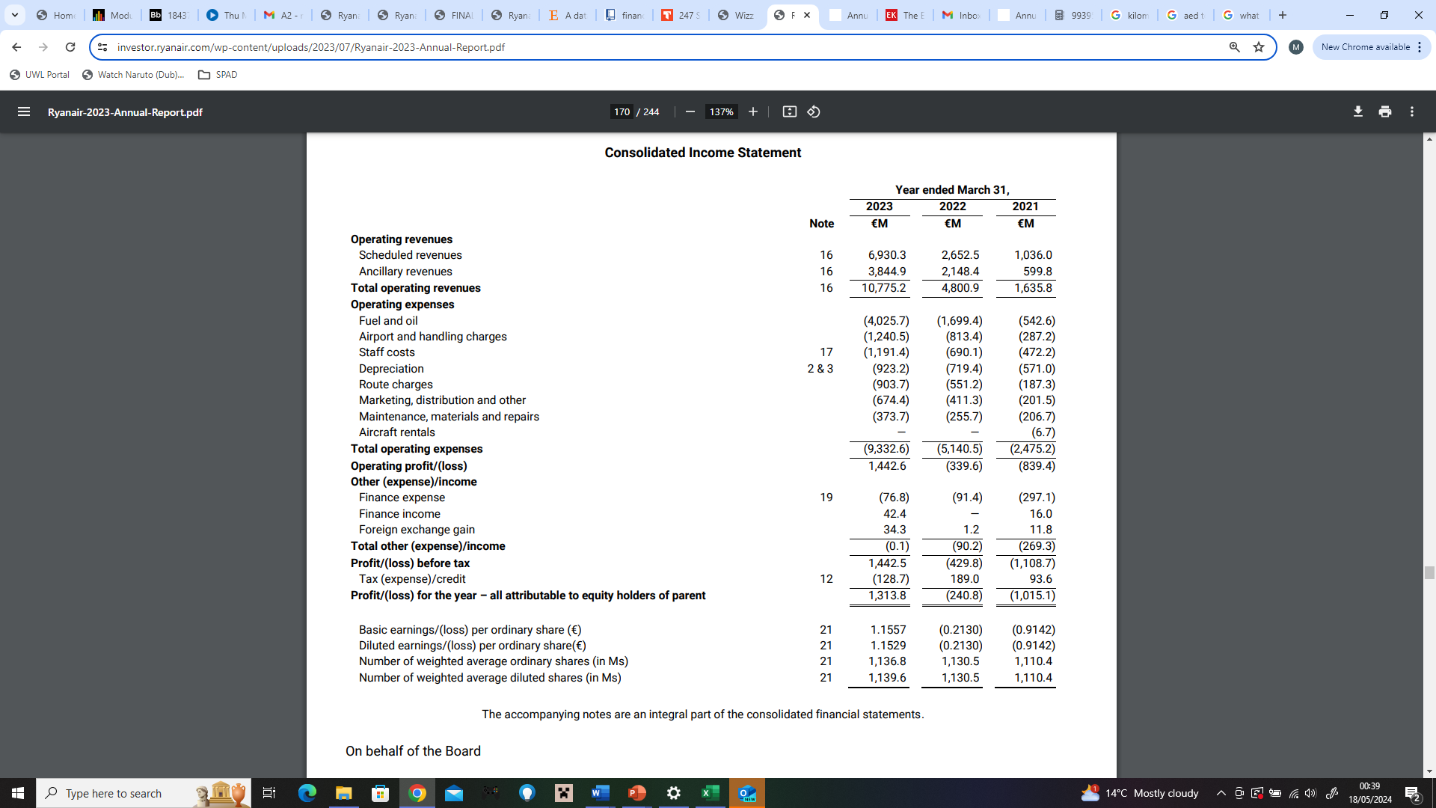

Fuel is one of the highest expenses for Ryanair in 2021 it was the second highest expense and in 2022 it was the highest expense. This was due to rising fuel costs that the industry was facing along side the increase in passenger demand. However, Ryanair have been hedging their fuel for the future to have lower costs as well as using new and efficient aircraft to minimise the cost (Ryanair, 2022b).

2.2.3 Staff Costs



Looking at another big expense, is the staff cost Ryanair must account for. Even in this category Ryanair aims to keep these costs as low as possible. Some have accused them of making staff pay for their own uniform and training. As well as encouraging staff to take un-paid leave during the off seasons, to reduce their costs on staff (Bérastégui, 2022) (Travel, 2013).

Source: (Statista Research Department, 2023)

2.2.4 Depreciation & Amortization



While these expenses grew by 28% in absolute terms, from €719 million in fiscal year 2022 to €923 million in fiscal year 2023, Ryanair's depreciation per passenger fell by 26%. The delivery of 37 new Boeing 737- and increased aircraft utilisation (sectors up 52%) were the main causes of the increase in amortisation (2022 report Ryanair)

3.0 Liquidity

|  |  |  |
| --- | --- | --- |
|  | 2021 | 2022 |
| CASH & CASH EQUIV | € 2,650,700,000 | € 2,669,000,000 |
| WORKING CAPITAL | -€ 68,600,000 | € 76,400,000 |
| CURRENT RATIO | 0.98 | 1.01 |
| NET DEBT | € 10,797,600,000 | € 11,284,500,000 |

Table 5 - Liquidity

Liquidity is the term used in what assets or security a company can convert into cash without affecting the market. We may compare airlines to determine how liquid they are by using the current ratio. A company should ideally have a score higher than 1, indicating that it can meet its immediate responsibilities (Hayes, 2024). The best current ratio is between 1.2 and 2 which indicates that the company can cover their liabilities, but over 2 means that a company is not effectively investing their money (FreshBooks, 2023).

Even in the lowest year with air travel due to Covid restrictions, Ryanair had managed a 0.98 on their current ratio. Which is pretty good, considering they didn’t have the cash flow that they were expecting. But this is also because Ryanair aims to hold large unrestricted cash positions which enable it to cover future financial liabilities, maintaining a strong liquidity for the company (Fitch Ratings, 2023).

Another reason for their increased cash & cash equivalents are that Ryanair have better Return on Equity (ROE) which means shareholders or potential shareholders find it more appealing to investing overall raising the price of the company (Norris, 2013).

4.0 Debt

|  |  |  |
| --- | --- | --- |
|  | 2021 | 2022 |
| DEBT-EQUITY RATIO | 1.65 | 1.39 |
| TIMES INTEREST EARNED | -12.03 | -3.72 |
| NET DEBT to EBITDA | -8.48 | 3.82 |

Table 6 - Debt

The Debt Equity (D/E) ratio shows how much debt a company has in comparison with their assets. More specifically looking at the shareholder equity. A lower D/E ratio means that the company is acting more safely, however if it is too low, it may represent that the company is not leveraging its assets well, which limits its profitability. A good D/E Ratio would be around 2 to 2.5 (Staff, 2022).

Reasons for lower D/E ratios for Ryanair could be due to their main goal being to have zero net debt by 2024. Their ratios reflect trying to maintain a long-term sustainability due to the volatility of the airline industry (Wondurrrrboy, 2020).

2021 was not the best year for Ryanair on the debt side of things, but most airlines had also suffered as a result due to COVID reasons, and many companies accumulated government loans during this time. However, we see Ryanair try to maintain a lower amount in the following year reducing this to -3.72. This was achieved in multiple ways, one was to acquire favourable interest rates on their loans to be able to cover their capacity much better (Guru Focus, n.d).

5.0 Conclusion

As seen from the data acquired Ryanair struggled in 2021, however, had strategies in place to minimise the losses that would have been incurred. In 2022 they made a big financial recovery and are set to improve in their profits through the use of new and efficient aircraft to reduce fuel costs. They aim to have zero net debt in the future and are working towards it, despite the challenges that have arisen trough the last few years.

6.0 References

Barnett, A. (2020) *Covid-19 risk among airline passengers: Should the middle seat stay empty?* [Preprint]. doi:10.1101/2020.07.02.20143826.

Bérastégui, P. (2022) *Ryanair cabin crew on strike over poor pay and working conditions | Etui*, *etui*. Available at: https://www.etui.org/news/ryanair-cabin-crew-strike-over-poor-pay-and-working-conditions (Accessed: 11 May 2024).

Chinazzi, M. *et al.* (2020) ‘The effect of travel restrictions on the spread of the 2019 novel coronavirus (COVID-19) outbreak’, *Science*, 368(6489), pp. 395–400. doi:10.1126/science.aba9757.

EasyJet (2022) *EasyJet plc - investors - reports and presentations*. Available at: https://corporate.easyjet.com/investors/reports-and-presentations/2018/ (Accessed: 10 May 2024).

Emirates (2022) *The Emirates Group Annual Report | 2022-2023*. Available at: https://c.ekstatic.net/ecl/documents/annual-report/2022-2023.pdf (Accessed: 09 May 2024).

Fitch Ratings (2023) *Fitch Upgrades Ryanair to ‘BBB+’; Stable Outlook*, *Fitch Ratings: Credit Ratings & Analysis for Financial Markets*. Available at: https://www.fitchratings.com/research/corporate-finance/fitch-upgrades-ryanair-to-bbb-stable-outlook-17-07-2023 (Accessed: 17 May 2024).

FreshBooks (2023) *What is a good liquidity ratio?*, *FreshBooks*. Available at: https://www.freshbooks.com/hub/accounting/good-liquidity-ratio#:~:text=A%20good%20current%20ratio%20is,liabilities%20to%20covers%20its%20debts (Accessed: 16 May 2024).

The Guardian (2009) *Ryanair toilet charge is no joke, insists O’Leary*, *The Guardian*. Available at: https://www.theguardian.com/business/2009/mar/05/ryanair-toilet-charge (Accessed: 11 May 2024).

Guru Focus (no date) *Ryaay (Ryanair Holdings) effective interest rate on debt %*, *RYAAY (Ryanair Holdings) Effective Interest Rate on Debt %*. Available at: https://www.gurufocus.com/term/effective-interest-rate/RYAAY (Accessed: 15 May 2024).

Hao, E. (2014) *Ancillary revenues in the airline industry: Impacts on revenue management and distribution systems*.

Hayes, A. (2023) *Operating income*, *Investopedia*. Available at: https://www.investopedia.com/terms/o/operatingincome.asp#:~:text=Operating%20income%20is%20the%20amount,tied%20to%20the%20core%20business. (Accessed: 06 May 2024).

Hayes, A. (2024) *Understanding liquidity and how to measure it*, *Investopedia*. Available at: https://www.investopedia.com/terms/l/liquidity.asp (Accessed: 18 May 2024).

Hazel, R. (2018) ‘Airline capacity discipline in the U.S. domestic market’, *Journal of Air Transport Management*, 66, pp. 76–86. doi:10.1016/j.jairtraman.2017.10.009.

Kenton, W. (2021) *Revenue per available seat mile (RASM): Overview, calculations*, *Investopedia*. Available at: https://investopedia.com/terms/r/revenue-per-available-seat-mile-rasm.asp (Accessed: 10 May 2024).

KÖSE, Y. and AKTAN, C. (2022) ‘Analysis of cost structures and cost control strategies of airlines: An empirical study on a hypothetical airline company’, *Journal of Aviation*, 6(1), pp. 42–49. doi:10.30518/jav.1024489.

Norris, B. (2013) *‘ryanair and the importance of high roe for growth and dividends’*, *Argonautica Blog*. Available at: https://www.argonautcapital.co.uk/blog/articles/2013/03/20/ryanair-and-the-importance-of-high-roe-for-growth-and-dividends/ (Accessed: 15 May 2024).

O’Connell, J.F. and Warnock-Smith, D. (2013) ‘An investigation into traveler preferences and acceptance levels of airline ancillary revenues’, *Journal of Air Transport Management*, 33, pp. 12–21. doi:10.1016/j.jairtraman.2013.06.006.

Ryanair (2022a) *Our news*, *Ryanair Reports Full Year Loss Of €355m – Ryanair’s Corporate Website*. Available at: https://corporate.ryanair.com/news/ryanair-reports-full-year-loss-of-e355m/ (Accessed: 09 May 2024).

Ryanair (2022b) *Ryanair-2022-annual-report*. Available at: https://investor.ryanair.com/wp-content/uploads/2022/07/Ryanair-2022-Annual-Report.pdf (Accessed: 05 May 2024).

Segal, T. (2024) *Profit margin: Definition, types, uses in business and investing*, *Investopedia*. Available at: https://www.investopedia.com/terms/p/profitmargin.asp#:~:text=%25%2025%25%200%25-,What%20Is%20Profit%20Margin%3F,subtracting%20all%20of%20its%20costs. (Accessed: 06 May 2024).

Soyk, C., Ringbeck, J. and Spinler, S. (2018) ‘Revenue characteristics of long-haul low cost carriers (LCCS) and differences to full-service network carriers (FSNCs)’, *Transportation Research Part E: Logistics and Transportation Review*, 112, pp. 47–65. doi:10.1016/j.tre.2018.02.002.

Staff, S. (2022) *What is debt-to-equity ratio? definition and guide - shopify UK*, *Shopify*. Available at: https://www.shopify.com/uk/blog/what-is-debt-to-equity-ratio (Accessed: 16 May 2024).

Statista Research Department and 18, O. (2023) *Ryanair: Employment figures by type 2023*, *Statista*. Available at: https://www.statista.com/statistics/1038876/ryanair-employement-figures-by-type/#:~:text=As%20of%20the%20fiscal%20year,group%20within%20the%20staff%20body. (Accessed: 08 May 2024).

Steiner, J.E. (1967) ‘Aircraft evolution and airline growth’, *Financial Analysts Journal*, 23(2), pp. 85–92. doi:10.2469/faj.v23.n2.85.

Sun, X., Wandelt, S. and Zhang, A. (2022) ‘Covid-19 pandemic and Air Transportation: Summary of recent research, policy consideration and future research directions’, *Transportation Research Interdisciplinary Perspectives*, 16, p. 100718. doi:10.1016/j.trip.2022.100718.

Sun, X., Wandelt, S. and Zhang, A. (2023) ‘A data-driven analysis of the aviation recovery from the COVID-19 pandemic’, *Journal of Air Transport Management*, 109, p. 102401. doi:10.1016/j.jairtraman.2023.102401.

Travel, A. (2013) *Ryanair staff made to buy £360 uniform and only paid for Time ‘in the Air’*, *Click here to refresh*. Available at: https://www.aol.co.uk/2013-05-18-ryanair-staff-exploited-mp-luciana-berger.html?guccounter=1&guce_referrer=aHR0cHM6Ly93d3cuZ29vZ2xlLmNvbS8&guce_referrer_sig=AQAAAIWMwAb7UogNtIOat46d9SLfm2WE3vp3L5oGQdl1_99CV0dhm9bT1dqpaUMJ5zHjgsTKt3l5clYqaNDfD8pbI5_0T2BACLjVq0THlcLLD-fMyYrEgCJC69QpjLRKwYQZLcM7u1CurruGkLajm8uBjSggjFG5b9BQZdfmexrmryfe (Accessed: 11 May 2024).

Wizz Air (2022) *Wizz Air Holdings PLC annual report and accounts ...* Available at: https://wizzair.com/static/docs/default-source/downloadable-documents/corporate-website-transfer-documents/annual-reports/wizz_air-annual-report-and-accounts-f22_final---pwc-confirmed_061d7bd2.pdf (Accessed: 18 May 2024).

Wondurrrrboy (2020) *Wondurrrrboy*, *LG’s Musings*. Available at: https://wondurrrrboy.wordpress.com/author/wondurrrrboy/ (Accessed: 15 May 2024).

7.0 Appendix

7.1 Appendix A

**Consolidated Balance Sheet 2021**

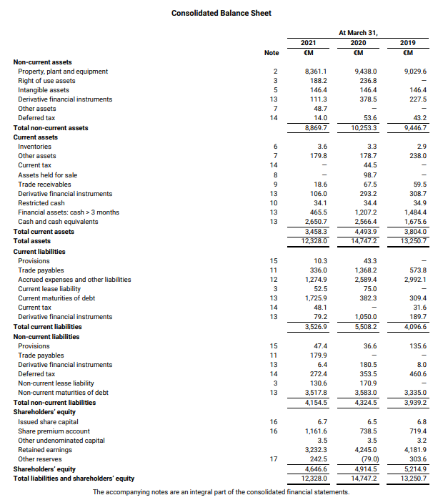

**Consolidated Income Sheet 2021**

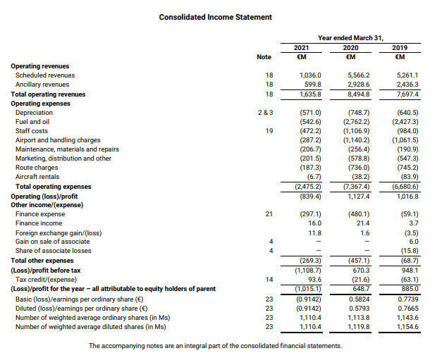

**Consolidated Balance Sheet 2022**

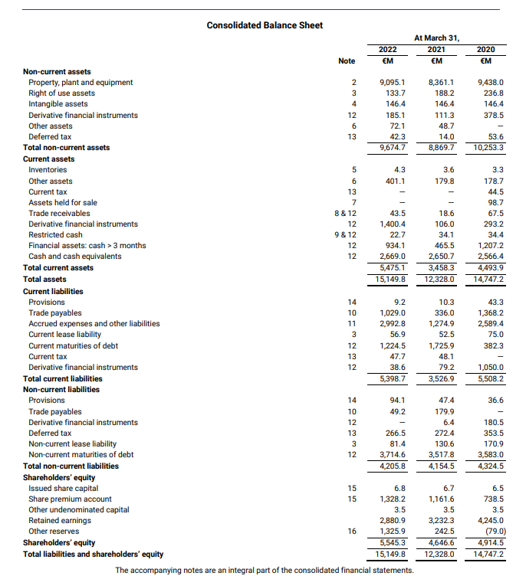

**Consolidated Income Sheet 2022**

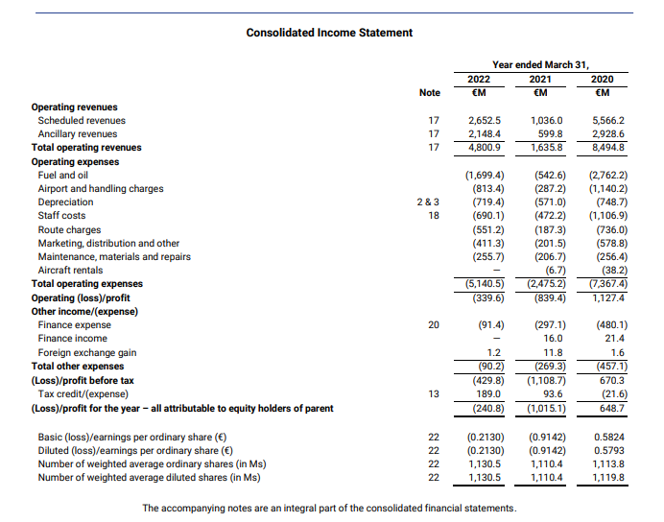

7.2 Appendix B

**Metrics Calculations 2021**

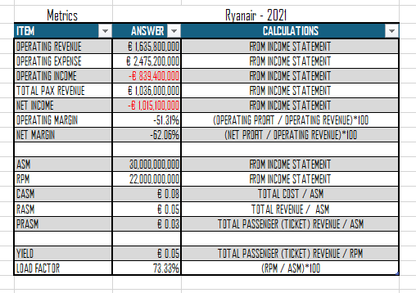

**Metrics Calculations 2022**

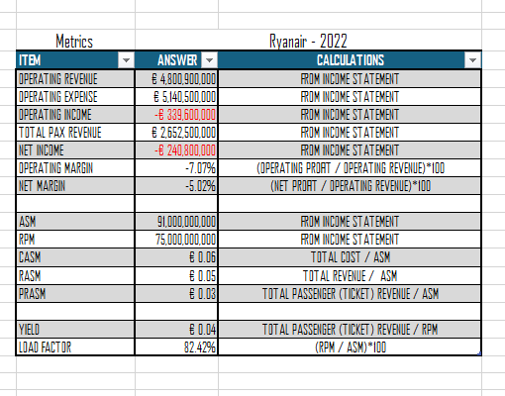

**Percentage Difference 2021 vs 2022**

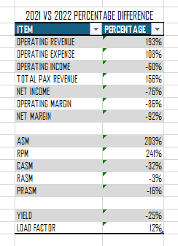

**Ratio Calculations 2021**

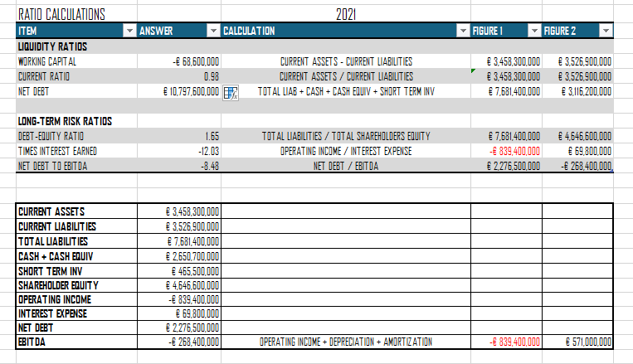

**Ratio Calculations 2022**

